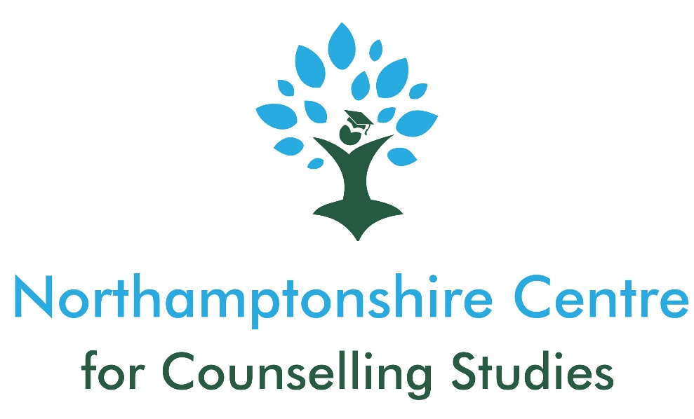

CPCAB LEVEL 4 DIPLOMA IN THERAPEUTIC COUNSELLING (including a 10-week module related to working with Children and Young People)
COURSE BROCHURE

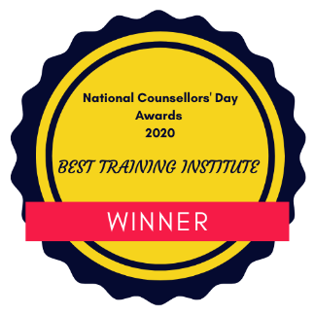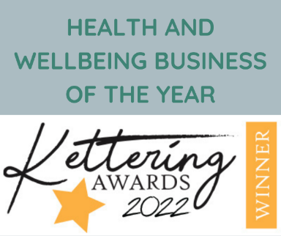

Course Overview
Qualification: | CPCAB Level 4 Diploma in Therapeutic Counselling (Person-Centred)
Hours: | 420
Awarding Body: | Counselling & Psychotherapy Central Awarding Body (CPCAB)
Fees: | £5200 plus £718 CPCAB registration fee (£359 per year of course). £200 discount if paying in full.  Flexible payment options available
Lead Tutor: | Kelly Porch NCCS (Accred.)
Co-Tutor: | Joanna Gilbert BACP (Reg.)
Commencing:  Days: | TBC  Wednesday Evening (6-8pm) – Online (Zoom)  One weekend a month (9am – 5pm) (Saturday and Sunday) x 20 whole weekends and two single sessions at a weekend – In-Person (Classroom)
Location: | Wellingborough (Service Six Community Rooms) and Online (Zoom)
Duration: | Two academic years
Additional Req. | Minimum of 30 hours personal therapy (must have undertaken a minimum of 15 hours for each year of the course)  100-hours of placement (to commence or be arranged before the start of Year 2)  Student membership of either the British Association for Counsellors and Psychotherapists (BACP) or National Counselling and Psychotherapy Society (NCPS).
Eligibility: | Must have completed Counselling skills and studies training e.g., CPCAB Level 2 Certificate in Counselling Skills and Level 3 Certificate in Counselling Studies or equivalent of at least 180 guided learning hours (i.e. hours live taught by a tutor). Please note, that distance learning courses are not accepted.
Interviews: | TBC – Places are limited (12 spaces in total)
How To Apply: (1) Before Interview: -
- Application form
- Application assignment
- A copy of photographic identification
- Copies of CPCAB Level 2 and Level 3 Certificates or equivalent (if you are yet to complete your Level 3 studies evidence of enrolment on a Level 3 course)

(2) Your application form will be assessed and if successful: -
- Provide requested information from your CPCAB Level 3 (or equivalent) portfolio
- Attend a 60-minute interview

(3) If successful at interview, you will be offered a place on the course pending deposit payments, returned Terms and Conditions and references (professional and from your CPCAB Level 3 [or equivalent] course tutor using the forms provided).

The Training Centre

The Northamptonshire Centre for Counselling Studies (NCCS) is an award-winning counselling training centre - recently winning the Health and Wellbeing Business of the Year at the Kettering Business Awards 2022 and the Best Training Institute in 2020 (National Counselling Awards). It was first established in 2016 and operates in Wellingborough, Northamptonshire for classroom-based courses, and online, (involving live, synchronous, teaching using Zoom).
We are currently working towards obtaining accreditation for the Level 4 course.
In addition to offering counselling courses, Levels 2 – 4, we also offer various CPD courses, such as: Understanding Equality and Diversity Law; Introduction to Listening Skills; Counselling for Chronic Pain/Illness; and more.
NCCS considers itself to be a ‘gatekeeper’ to the counselling profession and because counselling is still an unregulated profession, we take this responsibility very seriously. We have been assessed via internal and external quality-assurance procedures as being a training centre that has high expectations of its students. To enable students to work to these high standards, we also have equally high expectations of our staff and of the courses we provide. We therefore ensure that our courses not only focus on teaching the theory and skills of counselling but also the practical elements of being a counsellor so that we know any fully qualified counsellor leaving the centre can practice safely and ethically.
Our staff come from a variety of backgrounds and their knowledge and expertise cover a variety of different areas including systemic therapy; relationship counselling; addictions; LGBTQ+ issues; working with children and young people; private practice; chronic health/pain; domestic abuse; trauma; and much more.
It is important to us that all tutors are practicing counsellors. This means that they are up to date on current counselling policy and relevant legislation as well as being exposed to a wide range of client presenting issues that inform their teaching practice. Many of the tutors are also practicing clinical supervisors who supervise the practice of other counsellors.

Courses are reviewed regularly, and we conduct regular student surveys to ensure that we are making any necessary adjustments and adaptations to courses. We also keep class sizes small:
- 12-15 students (maximum) on Level 2 and 3
- 12 students (maximum) for Level 4

As a private training centre there are some limitations to what we can offer compared to larger training centres such as Further Education colleges or Universities. These include not being able to offer official student funding (e.g., Advanced Learning Loans), a library, cafeteria/coffee shop, unlimited breakout rooms and 1-2-1 specialist support for learning needs.
However, we love that we are a small, intimate training centre and are student-focused, offering that ‘personal touch’ that is outlined in the NCCS values where our students feel important and can have more focussed, direct contact with tutors, other centre staff and the Centre Manager.

The Diploma Course
The Level 4 Diploma course offered at NCCS is delivered by experienced tutors, supervisors, and other support staff, who work within, or are familiar, with the counselling profession. By the end of the course, our aim is for you to have developed the skills and knowledge to work as a professional counsellor including, but not limited to: -

- Working with a wide range of client issues
- Undertaking counselling assessments
- Confidence in working with client risk
- Ability to make referrals
- Note-taking
- Understanding and working within the law
- Working within a person-centred theoretical framework
- Effective utilisation of supervision
- Exploration of the realities of a counselling career
- Counselling young people

The diploma course that we offer doesn’t just focus on theoretical concepts but also the opportunity for self-development (often through experiential tasks) to enhance a student’s self-awareness so that they can work effectively with clients and achieve relational depth in their work. We endeavour to create a safe environment in which students feel able to undertake this important reflective work.
The relationship between a counsellor and client is one of the most important factors of successful therapeutic outcomes and at NCCS we make every effort to make courses relational to bring the heart of counselling into the training. You will gain a deep grounding in person-centred theory, whilst encouraging self-development to support the student in making unconscious/implicit material more conscious and explicit.

Here are some examples of some of the topics we cover on level 4: -

- Professional practice: professional boundaries and skills, working ethically and safely, understanding the law, working with suicide risk, organisational policies, and procedures, undertaking assessments and referrals, understanding ethical frameworks and application to practice by exploring ethical dilemmas, utilising supervision effectively, clinical wills and note-taking.

- Mental Health: exploration of the medical and non-medical models of common mental health issues, including medication and referrals to specialist services.

- Theory: A firm grounding in person-centred theory and its application to practice. Other theories will be touched upon as a starting point for further CPD after the diploma course.

- Working with Difference: Exploration of the implications of working with difference in counselling practice and ‘getting comfortable with being uncomfortable’.

- Self-Awareness: Opportunities to explore your early experiences and the impact of these on patterns of relating and/or behaviour. Sometimes this may involve creative activities.

- Group Process: At regular intervals, you will spend an hour in group process which will provide opportunity for exploring your inter-relational dynamics and your own process.

- Reflective Practice Groups: This is like group supervision and provides an opportunity to explore your development as a counsellor, linking theory to practice as well as discussions about what might come next after the diploma has ended.

- Additional Topics: Talking about sexual intimacy in the therapy room, attachment theory, time-limited counselling, and pre-trial therapy.

Counselling Young People Module
Towards the end of Year 1 of the diploma course at NCCS, students will also complete a 10-week module related to working with children and young people. This course is mapped across to Stage 1 of the “BACP Counselling Children and Young People Training Curriculum”. This module will provide students with the basic skills and competencies to begin working with children and/or young people. This will also provide students with a starting point should they wish to continue working towards a qualification in counselling children and/or young people once they have completed the Level 4 diploma at NCCS.

Personal Therapy
You are required to undertake 30 hours (a minimum of 15 hours per year of the course) of personal therapy with a qualified counsellor who must be a registered member of a counselling professional membership body. You can find your own counsellor but can seek advice and guidance from your tutors if you are unsure who to choose.
Placement
You will undertake a supervised placement within an agency that has an established counselling service. You must gain a minimum of 100 placement hours to pass this part of the course. You are required to find your own placement, however, NCCS has links to different agencies across Northamptonshire (and a few outside of the County) and we will be able to provide information about these. You will also have regular placement workshops to receive support in finding a suitable placement. Services in Northamptonshire include, Northamptonshire Mind, Teamwork, Service Six and The Lowdown. If you wish to work for an agency that we don’t have current links with, we are more than happy to consider this but the agency must go through the NCCS approval process first.
Should you wish to work with Young People in your placement and this is to begin prior to completing the Young People module within the course, you will be required to complete a selection of modules from the MindEd training programme in your own time alongside the demands of the Level 4 course.. We can provide the selected modules prior to the course beginning should you wish to get started on these.

Online Counselling - Placements
Since the pandemic, many agencies have decided to continue to offer counselling online only and some are offering a hybrid approach of both online and in-person counselling. You will need to consider your preferences when choosing a placement.
Should the placement you choose require you to work online (telephone or video calls), most placement agencies will require you to have undertaken some form of training in relation to this delivery method.
The CPCAB candidate guide has also been updated to reflect this change of approach to the provision of counselling and there are now assessment criteria related to this.
Some agencies are happy to accept a short training course, but others will expect a more in-depth 80- hour training course – this will therefore need to be undertaken at your own expense and in your own time either before the L4 course begins or alongside it. Should you choose the shorter training courses, this may limit the number of agencies you can apply to for placement. Examples of recognised training accepted by many agencies are: -
- https://www.open.edu/openlearncreate/course/view.php?id=5039 (6-hour course – Free)
- https://www.cpcab.co.uk/downloads/Counselling%20Tutor%20Online%20Course%20Info%20v.2.pdf (10-hour course written for CPCAB – Free)
- https://counsellingtutor.com/online-and-telephone-counselling-course/ (80-hour course - £140)

Should you undertake a hybrid approach to the provision of counselling in your placement, you must also comply with your membership body requirements: -
BACP- The majority of supervised practice hours must be conducted face-to-face with clients - the remainder can be a combination of online video or video and phone. For example, if the course
requires 100 hours of supervised placement hours, at least 51 hours must be conducted face-to-face (i.e., in the room). Text-based, asynchronous online practice cannot be counted towards the supervised placement hours in core practitioner training. Where remote placement hours are undertaken, the mode of supervision should be the same as that for the client work, so a mix of face-to-face and online supervision will be needed. All students will need appropriate supervision with a supervisor who has knowledge of, and experience in, delivering OPT sessions. The supervisor’s competence should be aligned with the BACP Supervision competence framework, which includes the OPT supervision competences.
NCPS- “It is required that at least 51% of placement hours are carried out face-to-face/in the-room. If the course provides relevant training and considers a student to be competent to carry out some of their supervised client hours remotely (i.e. online or phone-based), this will need to be synchronous/live and with relevant support from the placement provider and supervised by an experienced supervisor Within the remainder of hours permissible via remote working the decision with regards to the proportion of supervised hours for these other modes of delivery lies with the training provider. Asynchronous or text-based practice hours are not counted towards placement hours.”
Progression Routes
While undertaking a Level 4 diploma course at NCCS, you will be eligible for student membership of NCPS or the BACP. Once you have completed your course and gained your diploma, this will enable you to apply for full individual membership of these organisations or others. If you join NCPS or BACP, this will also include being placed on the Professional Standards Authority Register of Counsellors and Psychotherapists.
For the BACP, you will be required to sit a Certificate of Proficiency (a computer-based test) before being approved for the register. NCPS don’t require you to sit a test and will look at the counselling qualifications you have gained as proof of competency. NCCS is currently working towards gaining accreditation with NCS for its Level 4 diploma course.
From here, if you wish, you can work towards accredited status with either the BACP or NCPS (or other membership bodies). To become accredited, you will need to: -
- Have been ‘qualified’ for three years (this includes your Level 4 counselling placement)
- Have gained 450 hours of practice (this can include your Level 4 counselling placement hours)
- Have undergone 450 hours of counselling training with a substantial amount of this at Diploma level e.g., Level 3 plus Level 4 is 510 hours
- Be a registered member of the organisation you are hoping to gain accreditation with
- Be in supervised practice

The Level 4 diploma is a stand-alone course, but progression is available, should you choose to, on to the CPCAB Level 5 Diploma in Psychotherapeutic Counselling or Cognitive Behavioural Therapeutic Skills and Theory or the Level 5 Diploma Working in Counselling Children and Young People.
Completion of the Level 4 diploma can also contribute towards the requirements for the Open University Foundation Degree.

Eligibility Requirements
- To be 20 years old or over
- Hold a Level 2 Certificate in Counselling Skills and Level 3 Certificate in Counselling Studies or equivalent of at least 180 guided learning hours. Proof of this will be required prior to interview. The courses must have involved live teaching from a tutor and not distance learning
- To have a good track recording of attendance and meeting deadlines throughout your L2 and L3 training (evaluated through previous tutor references if transferring from a different training centre)
- Level 2 or equivalent in English Language – or ability to demonstrate this
- Good IT skills – ability to use Word, fill in proforma templates electronically, attach documents to emails and send, use an online classroom platform
- An ability to identify reasons for training beyond just personal development
- Provide academic and professional references
- Academically and emotionally able to cope with this level of training
- Ability to work with difference and diversity
- Possess personal qualities of resilience, imagination, intuition, openness, and ability to benefit from self-development
- Ability to form a therapeutic relationship
- Self-awareness, insight, honesty, and the ability to make links
- Ability to challenge and be challenged
- Ability to respond sensitively and empathically to others
- Capability (psychologically and time available) to commit to working with clients within an agency setting
- Are intending (and actively seeking) to secure a counselling placement by the end of year 1 of the programme
- Emotional stability and the absence of personality disturbance. Applicants who are experiencing current emotional or psychological problems will not be accepted onto the course. If you have experienced anything in the past this will be asked about at interview and you will be expected to have sufficiently worked through this
- Applicants who are experiencing current significant life circumstances or expecting significant life circumstances may not be accepted onto the course

It is important that you have carefully considered all the eligibility requirements before applying for the diploma course. You need to have enough emotional energy and time available to be able to successfully apply yourself to all aspects of the training. A discussion with your current course tutor or personal therapist may help you with this consideration.

Theoretical approach
The core theoretical approach taught at NCCS is Carl Rogers’ Person-Centred approach (PCA). The PCA has a humanistic foundation which in a nutshell believes that we all deserve non-judgemental attention to fulfil our potential in our own time and in our own way.
Rogers’ core conditions of empathy, warmth and unconditional positive regard are believed to be necessary for this growth and change to take place. The relationship between the counsellor and client is also at the heart of person-centred counselling.

Person-centred counsellors recognise and believe that:

- Each person has the capacity to self-heal and personally grow towards a concept called self-actualisation
- Each person has an organismic self-made up of actual experience and individual awareness and a self-concept which is often described as a distortion of the true, organismic self
- Each person has the potential of higher self-worth if their self-concept and organismic self are more consistent with each other
- The counsellor can create the core therapeutic conditions in their relationship with a client. This is necessary and sufficient for clients to become more in touch with their organismic self, be more able to grow and develop in a healthy way, be more accepting of unwanted aspects of themselves and more ale to make choices

Using the PCA, the courses taught at this teaching centre are experiential in nature with the aim of leading to personal development and change within each student which is necessary for working with clients at relational depth.

NCCS Diploma Team
Kelly Porch – Core Tutor
In addition to being the course lead and one of the core tutors for the Level 4 diploma course, Kelly is also the founder and Centre Manager of NCCS. In addition to this, Kelly is a qualified Person-Centred Counsellor working in private practice (Kelly Porch Counselling) where she helps clients (individuals and couples) presenting with many different issues. She has a particular interest in the provision of counselling for those who have been diagnosed with a chronic illness/pain and those who are in recovery from addiction.

Kelly is an accredited member of the National Counselling and Psychotherapy Society. She is also a qualified supervisor, providing clinical supervision for trainee and qualified counsellors and other professionals. Kelly is currently training to be a Solution-Focussed Hypnotherapist

In the past, Kelly has been Lead Counsellor at Moulton College and a volunteer counsellor within a local charity called, Teamwork. She has also taught the CPCAB Level 2 Counselling Skills at Bedford Further Education College.

Kelly is also qualified to teach the Level 2 Introduction to Counselling Skills, Level 2 Certificate in Counselling Skills and Level 3 Certificate in Counselling Studies

Studies.

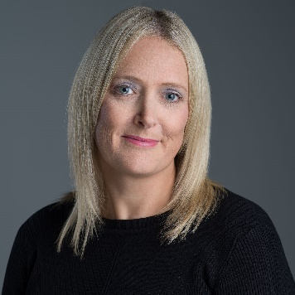

Joanna (Jo) Gilbert – Core Tutor
Jo has been a qualified Counsellor since 2013, is a registered member of the BACP and specialises in adolescent, couple, and family counselling. Jo is also a clinical supervisor for other counsellors.
Jo works within the Person-Centred approach as a core modality and integrates Systemic Therapy.
She has worked within a charity setting for 10 years providing one to one counselling for young people as well as group family sessions and works for Relate. She also runs a private practice.

Jo sometimes also teaches on the other levels of training at NCCS.
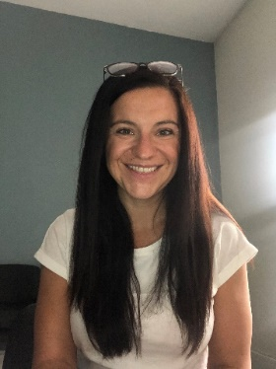

Fees and Payment Options
 | Option 1  (One Payment –  £250 discount) | Option 2  (Two Payments) | Option 3  (Instalments)
Non-Refundable Deposit | £500 (within 7 days of a place being offered on the course) | Year 1 - £500 (within 7 days of being offered a place on the course)  Year 2 - £500 (within 7 days of being offered a place on the course) | Year 1 - £500 (within 7 days of a place being offered on the course)  Year 2 - £500 (within 7 days of being offered a place on the course)
Balance | £5218 (£200 discount for paying in full included) | Year 1 - £2459  Year 2 - £2459 | Year 1 - £205 x 12 payments  Year 2 - £205 x 12 payments  If a student completes all aspects of the course before the 12 instalments have been paid, certificates won’t be released to the student until the balance has been paid
Total | £5718 | £5918 | £5920

Ts & Cs apply to all options
For all options, should you withdraw from the course, not be offered a place on Year 2, or be asked to leave the course early, the total 2-year course fee outlined above remains payable.
Additional Costs
- Student membership of a counselling professional membership body (either National Counselling Society [£60] or British Association for Counsellors and Psychotherapists [£82]) – correct at time of writing
- 30 hours of personal therapy (some counsellors offer student rates) – must complete 15 hours for each year of the course and sessions must be no less than once a fortnight
- Clinical supervision (if placement provider doesn’t provide this)
- Public liability insurance (if placement provider doesn’t provide this)
- Registration with Information Commissioners Office (if placement provider doesn’t provide this)
- Mandatory course textbooks
- Printing

Additional Learning and Support Needs
One of the five NCCS core values is ‘Inclusivity and Accessibility’ for all students, and we take this very seriously.

It can sometimes be the case that a student has additional learning needs. This might be to support with numeracy and/or literacy or with conditions such as dyspraxia, dyslexia, sight and hearing problems, emotional and mental health conditions. Learners may also have physical/health needs that may affect their learning experience. Most of these needs will be identified at your course interview but this might not always be the case and some needs can emerge during the training course.

NCCS is a small private training centre and so, unlike a Further Education College or University, we may not have the necessary resources to be able to fund your requirements or to reasonably provide the resources that you need. If you wish to train at NCCS and you have additional needs then you need to carefully consider whether a small, private training centre is suitable for you. Additional costs incurred could include specialist equipment, specialist tutor costs, extra tutorials outside of course time and so on.

It is the responsibility of a course applicant to disclose any disability, mental health conditions or anything else that may create a barrier to undertaking a Level 4 diploma course. You are required to stated explicitly what your supports needs are and how these may have been addressed on previous training courses. You will be asked about this at interview and should you have additional needs, we will have a conversation about any ‘reasonable adjustments’ that could be made.

If a specific need emerges once the course has begun, then we will arrange an additional tutorial with the student to see what can be done to support the student, including any ‘reasonable adjustments’ that can be made.

We always do our best to support students in any way that we can, but this will be within the remit of ‘reasonable adjustments’ in accordance with the Equality Act 2010.

Frequently Asked Questions
Why should I choose courses offered by NCCS?
NCCS is an award-winning training centre that provides robust, expert-led, high-quality counselling training courses that are approved provided by the Counselling & Psychotherapy Central Awarding Body (CPCAB). The CPCAB is a UK-based awarding body that is managed by professional counsellors, trainers and supervisors and are the only awarding body in Europe to specialise in the field of counselling.
CPCAB has grown to become the UK's leading specialist awarding body in counselling. Their success is based on their commitment to developing competent counsellors - they are the only awarding body run by counsellors for counsellors.
The CPCAB provide a coherent progression route to becoming a practicing counsellor in both a counselling agency, private practice and beyond to becoming a counselling supervisor. Undertaking CPCAB courses provides the necessary guided learning hours required for counselling accreditation should a practicing counsellor wish to undertake this in the future.

I have a psychology degree; can I use this as a contribution towards my counselling training and apply straight for Level 4?
Undertaking a psychology degree and counselling training are two different things.
While both cover similar aspects in relation to theory of personality, a psychology degree is a knowledge-based qualification which requires a high level of academic ability. This is compared to counselling training which is a relational activity which depends on personal qualities, self-awareness, and soft skills such as the ability to build a trusting relationship, work with difference and diversity and covey empathic understanding.
These aspects of counselling training are not included or assessed in most psychology degree programmes and must be learnt and developed in a very different learning context. You will need to start with the Level 2 Certificate in Counselling Skills (CSK-L2).

Do I have to start at Level 2?
If you have already gained counselling skills and theory qualifications with another awarding body, NCCS will look at the number of guided learning hours (GLH) undertaken in a classroom and what the course comprised of in relation to the learning of theory and practical skills practice. This will be compared to what is covered on the Level 2 course at NCCS.
To start at Level 4, potential students will have completed equivalent skills and theory courses comprising of at least 180 GLH
If you are unsure whether this relates to you then please contact NCCS and we will arrange a telephone conversation with you
At NCCS, online or distance learning courses that do not contain live teaching or regularly assessed skills practical sessions will not be accepted as recognised prior learning.

Can I train to be a counsellor via distance learning?
In a world where counselling is an unregulated profession, there is a wide range of training available and there is a place for distance learning or online courses, usually for Continuous Professional Development (CPD) once the formal counselling training has been completed or when combined with high-quality classroom based learning (e.g. The Open University/CPCAB Foundation Degree)
Good quality counselling training has a solid relational foundation at its core and NCCS believe that in the first instance, this cannot be achieved via online or distance learning that doesn't involve live, synchronous teacher or regularly assessed skills practice sessions
NCCS offers CPCAB courses which all incorporate regular live teaching and assessed skills practice sessions (either in the classroom or online) and provide the benefits of an environment that consists of experiential learning building counselling competence as each level of training is undertaken.
Professional membership bodies such as the British Association for Counsellors and Psychotherapists (BACP) or the National Counselling Society (NCS) require counsellors to register on an Approved Voluntary Register by the Professional Standards Authority (PSA). To do this the membership bodies and PSA insist that a proportion of the would-be counsellor's training is provided by live teaching.
BACP state: "We believe that practising counselling skills under supervision, and with feedback from staff and fellow students, is an important aspect of training. Online and distant learning courses can offer an introduction to the use of counselling skills and theory, but do not have this relationship with staff and other students".
Any online or distance learning courses undertaken that are not synchronous and don’t involve live teaching will also not count towards the training hours required for profession membership or accreditation should this be undertaken in the future once practicing.
At NCCS, online or distance learning courses that do not contain live teaching or regularly assessed skills practical sessions will not be accepted as recognised prior learning.

What funding is available for courses?
As a private training centre, funding in the form of learning loans and remitted fees are not available. However, to help spread the cost an instalment payment option is available once the deposit has been paid.

What is ScoPEd?
ScoPEd stands for Scope of Practice and Education and is a “shared standards framework, developed by six Professional Standards Authority accredited bodies….” including the BACP and NCS.
The aim of the framework is to, “provide those seeking the services of counsellors and psychotherapists who have adopted the framework with clear information on core training, practice and competence requirements so that they may make informed choices.”
It sets out, “a shared understanding of the training and practice requirements associated with different entry and progression points for the profession, and the core competences required for safe and ethical practice for counsellors and psychotherapists working with adults”.
The aim of the framework is to set out the minimum core training, practice, and competences a therapist can evidence in their practice.
How does this affect trainee counsellors?
The framework is deemed to be a resource that supports the integration of generic standards at the core of a counsellor’s practice and our Level 4 diploma meets all the requirements for access to Column A.
Our Level 4 diploma also meets most of the requirements for access to Column B. You will complete at least 100 client hours in a counselling placement as part of your diploma training which will leave a further 250 hours to complete before being able to access column B. Most of the academic requirements of column B will be met by the Level 4 diploma course.
Impact?
The framework has only recently been adopted by the professional membership bodies involved and so the impact of the framework remains to be seen. It can currently be utilised as a guide for all therapists to transition to the column of their choice

This will vary from student to student depending upon the previous course(s) undertaken but if you are unable to provide work requested, we will be unable to offer a place on the course

